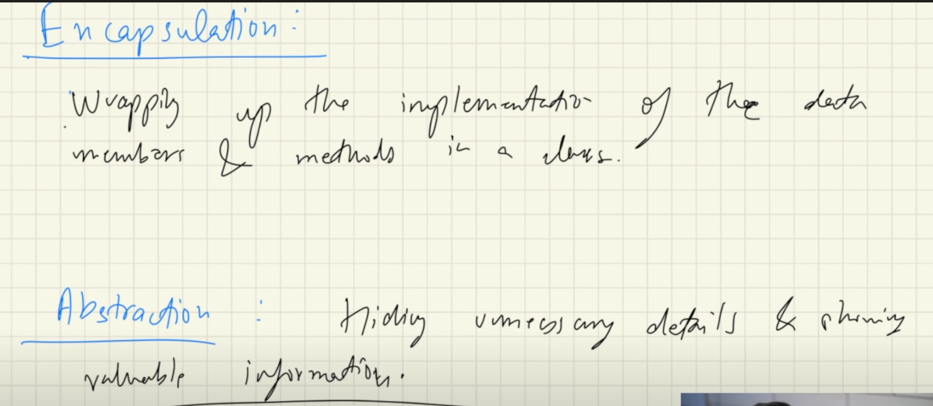

**Encapsulation**

Wrapping up the implementation of the data members and methods in a class

**Abstraction**

Hiding unnecessary details and only showing the valuable information. Like the customer do not need to know how the engine works when they press brakes, they just need to know that when they press brake the car stops

Example

We have class as ArrayList, and we are provided with many methods. One of such method is .add( )

Now we do not need to know the internal working of the .add( ) method, to work with the ArrayList object, we can do our work without knowing what’s going on

So there are also called abstract data types